Implement a custom dynamic array class that supports basic operations like insertion, deletion, resizing, and clearing.

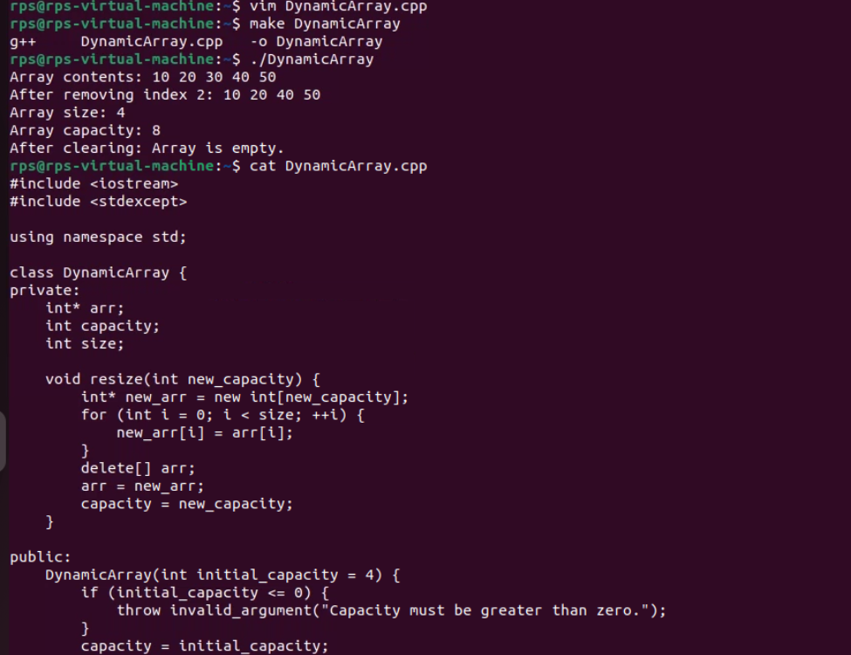

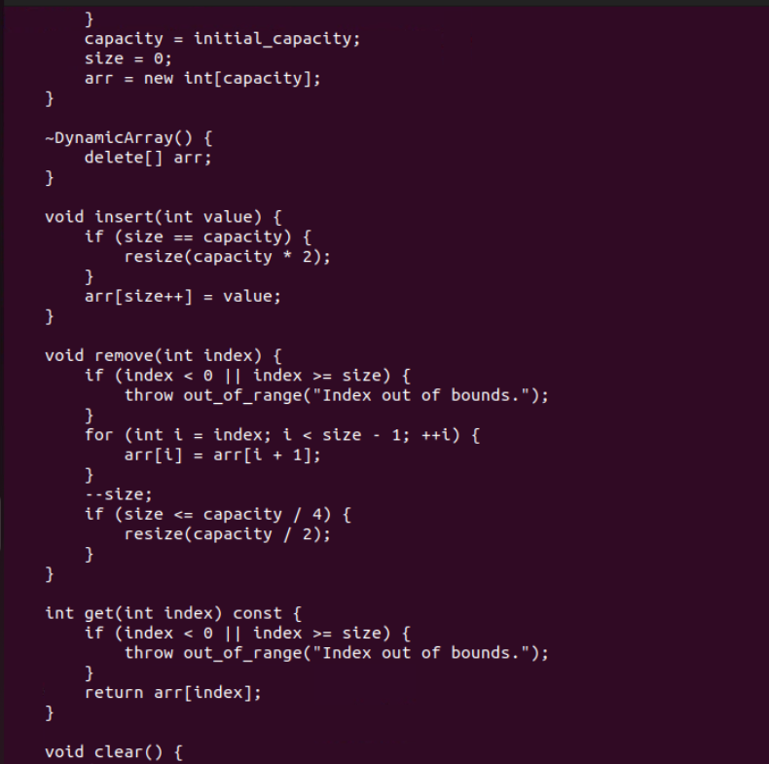

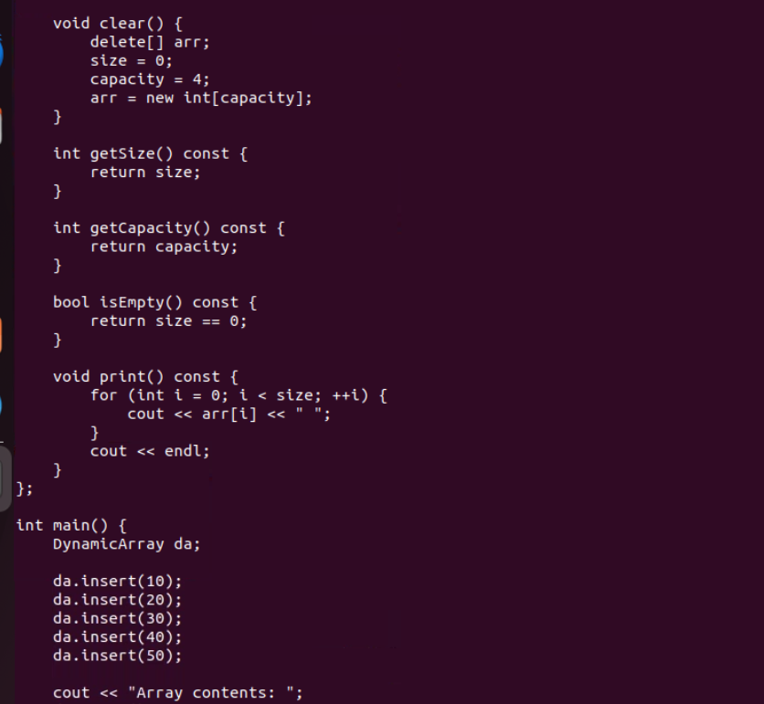

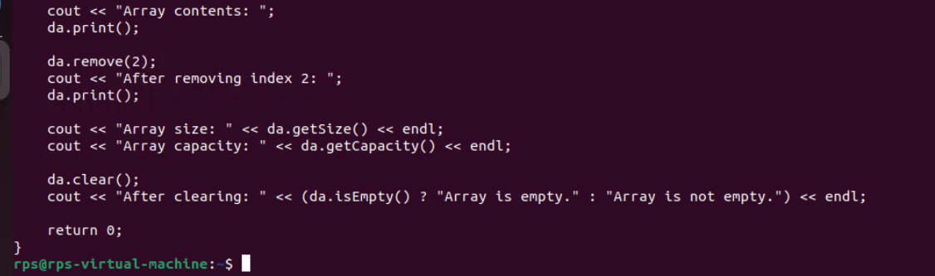

Create a template-based stack class supporting push, pop, and peek operations. Implement it for different data types like int, float, and std::string.

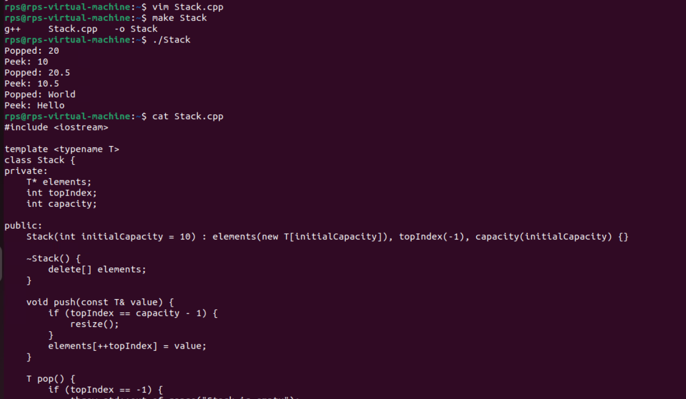

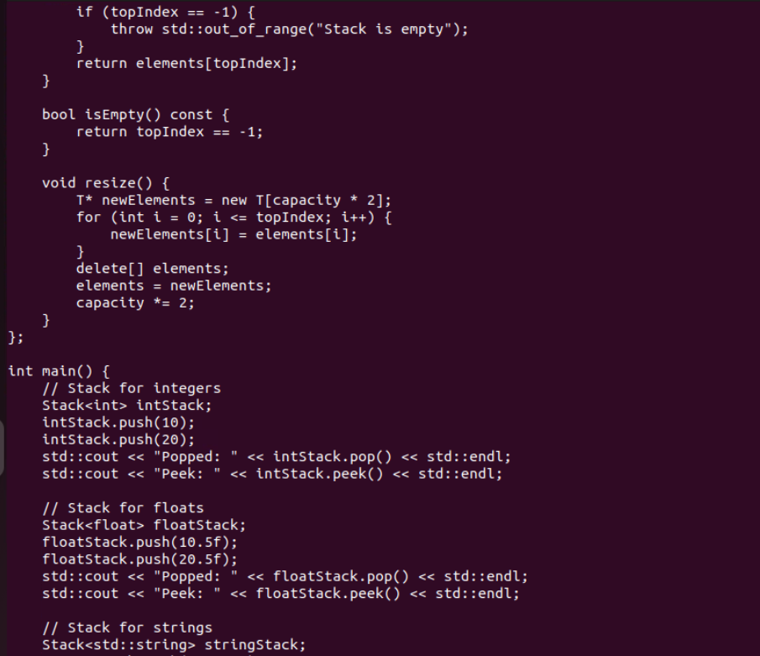

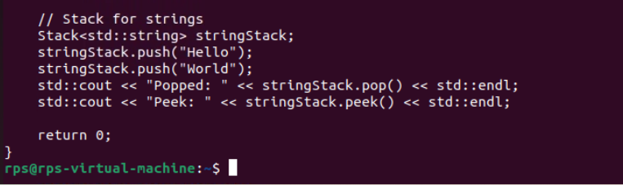

Write a program that reads from a file and handles various exceptions such as file not found, read errors, and unexpected data formats.

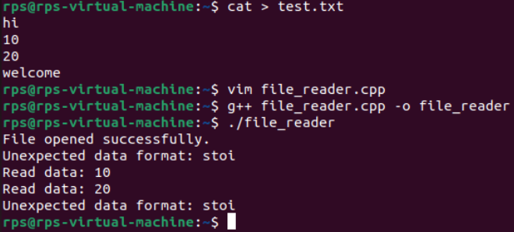

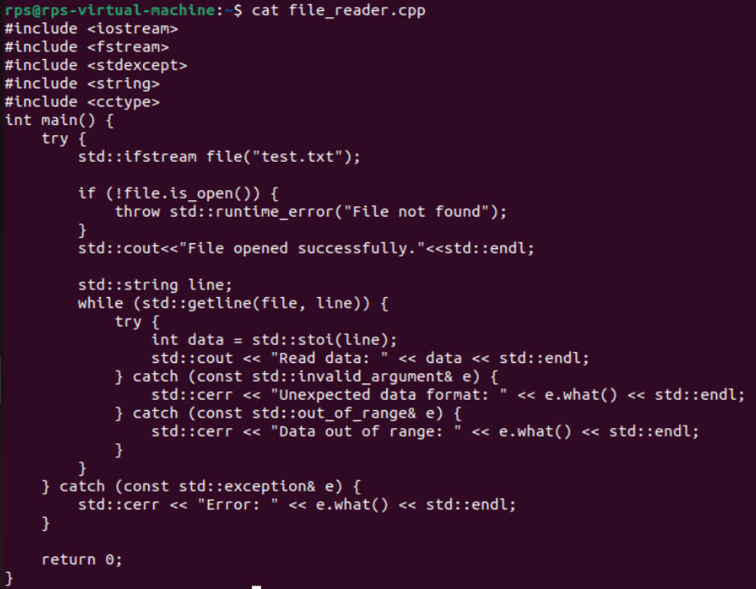

Write a unit test suite for the custom dynamic array class using a testing framework like Google Test or CppUnit**.**